|  |  |  |
| --- | --- | --- |
| xS1 | xS2 | QS+1 |
| 0 | 0 | S |
| 0 | 1 | QS |
| 1 | 0 | 0 |
| 1 | 1 | 1 |

Варіант 10

Таблиця переходів:

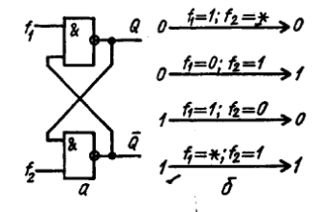

Повна таблиця переходів:

|  |  |  |  |  |  |  |
| --- | --- | --- | --- | --- | --- | --- |
| CS | xS1 | xS2 | QS | QS+1 | f1 | f2 |
| X4 | X3 | X2 | X1 |  |  |  |
| 0 | 0 | 0 | 0 | 0 | 1 | * |
| 0 | 0 | 0 | 1 | 1 | * | 1 |
| 0 | 0 | 1 | 0 | 0 | 1 | * |
| 0 | 0 | 1 | 1 | 1 | * | 1 |
| 0 | 1 | 0 | 0 | 0 | 1 | * |
| 0 | 1 | 0 | 1 | 1 | * | 1 |
| 0 | 1 | 1 | 0 | 0 | 1 | * |
| 0 | 1 | 1 | 1 | 1 | * | 1 |
| 1 | 0 | 0 | 0 | 1 | 0 | 1 |
| 1 | 0 | 0 | 1 | 0 | 1 | 0 |
| 1 | 0 | 1 | 0 | 0 | 1 | * |
| 1 | 0 | 1 | 1 | 1 | * | 1 |
| 1 | 1 | 0 | 0 | 0 | 1 | * |
| 1 | 1 | 0 | 1 | 0 | 1 | 0 |
| 1 | 1 | 1 | 0 | 1 | 0 | 1 |
| 1 | 1 | 1 | 1 | 1 | * | 1 |

Діаграми Вейча:

